MASo: masonry structures – seminar task

Design a masonry storage house (plan and section in the figure). The building has three floors and a basement floor located in the left third of the plan. The floors are connected through an outside fire-escape steel staircase; access to the basement is through the outer lift.
Horizontal load-bearing structures: ceramic-concrete composite structure
Vertical load-bearing structures: masonry pillars, masonry wall.
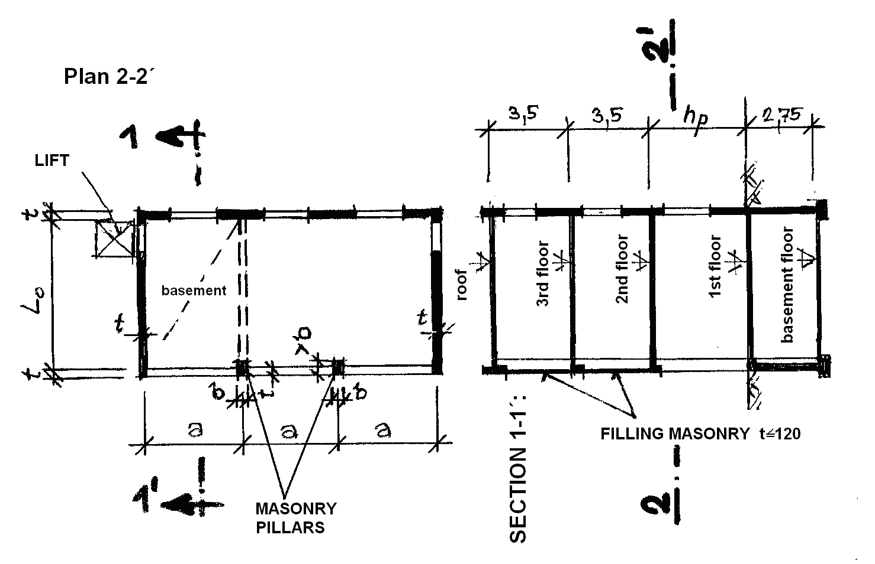
Work out:
Structural analysis:
- preliminary structural analysis of the ceilings and lintels
- detailed analysis of the pillar and load-bearing wall
- analysis of the cladding due to wind load
- analysis of the basement wall

Drawing of the general arrangement or the load-bearing structures of the ceilings (scale 1:50 or 1:100)
- of the 1st floor
- of the basement floor

Drawing of detailing (scale 1:10):
- bond of the bricks of the load-bearing wall
- bond of the wall at the corner
- bond of the pillar
- bond of the pillar at the corner with the gable wall
- modular composition in the vertical direction for the load-bearing wall and for the pillar
- two details of the slab supported on the lintel

For your design, use one of the following systems:

System Wienerberger (Porotherm)
Masonry units for outer load-bearing walls: POROTHERM 30 Profi DRYFIX, P10, P15 (247/300/249 mm), thickness of the wall 300 mm;
Ceiling: ceramic – concrete slab Porotherm, spacing of beams 500 mm;
Lintels: Porotherm 23,8 (70/238/1000 to 3250 mm), max. clearance 2750 mm;
Lintel above gates: monolithic (in-situ) – depth according to used masonry units;
Pillars: solid clay bricks TERCA Klinker P20 (240/115/71 mm);
Cladding in 2nd and 3rd floor: hollow bricks TERCA Klinker P60 (240/115/71 mm).

System Heluz
Masonry units for outer load-bearing walls: Grinded bricks HELUZ STI 30, P8, P10, P12, P15 (247/300/249m), thickness of the wall 300 mm;
Ceiling: ceramic – concrete slab HELUZ MIAKO;
Lintels: Jistrop 238 70/238/1000-3250 mm;
Lintel above gates: monolithic (in-situ) – depth according to used masonry units;
Pillars: bricks HELUZ CV 14, P20 (290/140/140 mm);
Cladding in 2nd and 3rd floor: HELUZ CDm (240/115/113 mm).

Individual parameters (specified in special excel file on teacher´s website):
a | b | t | L_{o} | h_{p} | Characteristic vertical load |  |  | Characteristics for the lateral load calculation
 |  |  |  |  | (g-g_{o})_{roof} | (g-g_{o})_{floor} | q_{floor} | terrain categories | wind velocity | bulk density
m | m | m | m | m | kN/m² | kN/m² | kN/m² | - | m.s⁻¹ | kg.m⁻³

(g-g_{o})_{roof} other permanent load for roof (load of the layers of roof cladding)
(g-g_{o})_{floor} other permanent load for floor (load of the layers of floor)
q_{floor} variable load for a storage;
q_{roof} = 1,5kN/m² (snow-load);
bulk density of the backfilling material: 1800 – 2000 kg.m⁻³ (for the design of a basement wall)
terrain category and reference wind velocity – see individual parameters

