Masonry building in sloping terrain
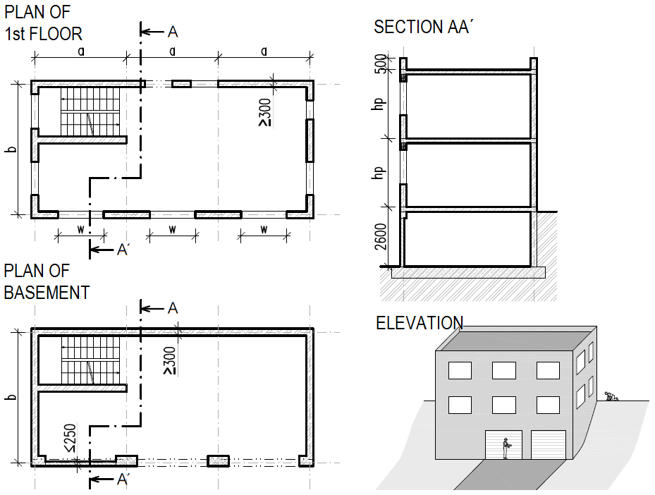

Geometry: a, b [m] – horizontal dimensions,
h_{p} [m] – height of above-ground floors,
w [m] – the widest window.
Materials: concrete C25/30,
steel B 500 B,
masonry, slabs, lintels – see the specification on 2nd page,
bulk density of soil γ [kg/m³].
Loads: other permanent load of typical floor (g-g₀)_{floor,k} [kN/m²],
other permanent load of the roof (g-g₀)_{roof,k} [kN/m²],
live load of typical floor q_{floor,k} [kN/m²],
live load of the roof q_{roof,k} [kN/m²] – snow (snow area),
wind load – wind area and terrain category.

Parameters in bold to be found in the excel file with individual parameters.

Please work out:
- Design of ceramic ceiling above 1st floor.
- Design of lintels above the widest window. Sketch section and elevation of window head in your structural analysis.
- Structural (assembling) drawing of the 1st floor. All the dimensions (including the assigned ones) will be adjusted appropriately in accordance with modular dimensions of masonry. In sections, describe both the typical detail and detail of window head.
- Design and check the load bearing capacity of masonry pillar between garage doors. Design the bond of bricks as well.
- Check the basement wall loaded by earth pressure at rest.
- Check the non-bearing wall next to garage door loaded by wind loads.

If something is not assigned, choose the value appropriately according to your consideration.

Specification of masonry elements
- Load-bearing walls: POROTHERM 30 Profi DRYFIX blocks P10 or P15 (247/300/249 mm).
- Pillars between garage doors: Full brick P20 (290/140/65 mm), general purpose mortar MC 10.
- Non-bearing wall next to garage door: SUPERTHERM 17,5 blocks P10, general purpose mortar MC 5.
- Ceramic ceiling: POROTHERM Slab – design according to tables.
- Lintels: POROTHERM 7 lintels – design according to tables.

