Design of symmetrically reinforced cross-section subjected to moment and normal force

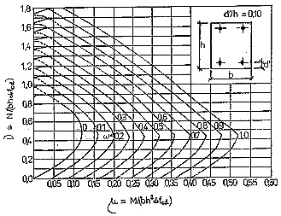
$ν=\frac{N_{\text{Ed}}}{{\text{bhf}}_{\text{cd}}}$ $μ=\frac{M_{\text{Ed}}}{{\text{bh}}^{2}f_{\text{cd}}}$ → ω from the chart

$ω=\frac{\sum{A_{S}⋅f_{\text{yd}}}}{{\text{bhf}}_{\text{cd}}}$ → $A_{s1}=A_{s2}=\frac{1}{2}\frac{ω⋅\text{bh}⋅f_{\text{cd}}}{f_{\text{yd}}}$

